**KARNATAK LAW SOCIETY’S**

GOGTE INSTITUTE OF TECHNOLOGY

UDYAMBAG, BELAGAVI-590008

(An Autonomous Institution under Visvesvaraya Technological University, Belagavi)

**(APPROVED BY AICTE, NEW DELHI)**

Department of Computer Science and Engineering



*A Project Report on*

***"Bookshop Management System"***

*Submitted for the requirements of III semester B.E. in CSE*

*for* ***“Advanced C and OOPS Laboratory”*** *Course* ***(16CSL36)***

***Submitted by***

**Name USN**

1) Mahejabeen Ustad 2GI16CS063

2) Mrunal Ambekar 2GI16CS068

3) Pratima Bhat 2GI16CS093

**Guide**

Asst. Prof. Mrs. M. M. Ramannavar

**Academic Year**

2017– 2018

**KARNATAK LAW SOCIETY’S**

**GOGTE INSTITUTE OF TECHNOLOGY**

UDYAMBAG, BELAGAVI-590008

(An Autonomous Institution under Visvesvaraya Technological University, Belagavi)

**(APPROVED BY AICTE, NEW DELHI)**

Department of Computer Science and Engineering



**CERTIFICATE**

*This is to certify that the Seminar entitled* ***"BOOKSHOP MANAGEMENT SYSTEM”*** *is a bona fide record of the Seminar work done by* ***MAHEJABEEN USTAD(2GI16CS063), MRUNAL AMBEKAR(2GI16CS068)*** *and* ***PRATIMA BHAT(2GI16CS093)*** *under my supervision and guidance, in partial fulfillment of the requirements for the Outcome Based Education Paradigm in Computer science and engineering from Gogte Institute of Technology Belagavi for the academic year 2017-2018*

Mrs. M. M. Ramannavar Dr.S.F.Rodd

(Guide) *Professor & Head*

*Asst. Professor Dept. of Computer science and Engineering*

*Dept. of Computer science and engineering*

Place: Belagavi

Date:

Department seal

**ACKNOWLEDGEMENTS**

I would like to express my special thanks of gratitude to **Dr.A.S.Deshpande**, Principal, KLS Gogte Institute of Technology, Belagavi, **Dr.S.F.Rodd,** Head, Dept. of Computer Science and Engineering as well as our Project guide **Asst. Prof. Mrs. M. M. Ramannavar** who gave us the golden opportunity to do this wonderful project on the topic **Car Rental System,** which also helped us in doing a lot of Research and learn new things. We are really thankful to them.Secondly we would like to thank **Teaching and Non-teaching faculty of CSE dept** who helped with the college resources. Finally I would like to thank our **Parents and Friends** for their support.

We are making this project not only for marks but also to increase our knowledge.

***Student Name***

***Pratima Bhat***

***Mrunal Ambekar***

***Mahejabeen Ustad***

**ABSTRACT**

Bookshop management system is a simple console application without graphics, developed using C programming language. It is important to collect the information of the customers because to offer the similar kind of books that they purchased before. Our project utilizes various aspects of C such as functions, arrays, pointers, file handling. With this simple application ,users can perform all the basic book-related operations and features provided by today's advanced bookshop management. We also used looping constructs in our program.

Using this program we can easily record the information of books that we are selling or buying. It also maintains the date of book that sold out along with the price. It is simple to implement. It stores the information like name of the customer, his mobile number etc. Using this method we can easily see the quality of books and there will be no confusion in price .It has certain limitations compared to online bookshop management system. However, this program gives us the satisfied result.

**Key Words***: Insert Records, Search Customer Details, Search Sales Details*

**TABLE OF CONTENTS**

|  |  |  |
| --- | --- | --- |
| **S.No** | **Contents** | **Page No** |
| 1 | INTRODUCTION | 07 |
| 2 | LITERATURE SURVEY  Existing systems | 08 |
| 3 | OBJECTIVES  Proposed System  Problem definition | 09 |
| 4 | SYSTEM REQUIREMENTS  Hardware and Software Requirements | 10 |
| 5 | SYSTEM DESIGN  Overall Architecture  Module level design | 11-12 |
| 6 | IMPLEMENTATION | 13 |
| 7 | TESTING | 14-16 |
| 8 | RESULTS and DISCUSSION | 17 |
| 9 | LIMITATIONS and FUTURE ENHANCEMENTS | 18 |
| 10 | CONCLUSION | 19 |
| 11 | REFERENCES | 20 |

**LIST OF FIGURES**

FIG. NO. PAGE NO.

5.1 OVERALL ARCHITECTURE 11

7.1 Screen Shot of Testing 14

7.2 Screen Shot of Testing 15

7.3 Screen Shot of Testing 15

7.4 Screen Shot of Testing 16

7.5 Screen Shot of Testing 16

**1.INTRODUCTION**

[1]This project on Bookshop management System explains about how Book Shops work with the computer application when any customer buys books from the store. Basically, the problem of book shop owner is to maintain the records of sales and customer’s information. It is better to store all these information in a software, than maintaining register books. So, we have developed the C program, which stores the customer’s as well as sold out information on that date. Therefore, it will be very convenient for the book shop owner .Admin of the book shop can get information about customer, like his name, phone number, the date when he purchased book etc and also admin can give a particular date to check no. of books sold out on that day and to know total amount earned on that day. The report generation facility of bookshop system helps to get good idea of sales.

**2.LITERATURE SURVEY**

**2.1 EXISTING SYSTEMS:**

As we are living in 21st century, all we need is more comfortable and luxurious life. At present we are living in computerized world. Computer application have affected scientific and commercial knowledge. The information system of the old times totally differs from the todays. It is the automation system of a bookshop or any information system. In the previous ages the process of maintaining data and record seem very difficult. Now a days computer is very essential component. The implementation of computer based information system can be depicted as the ease in handling and maintaining the data bank of any size.

[2]At present, the Wholesale and retail outlets are working under manual management. The client uses MS Excel, All records related to products, sales and payments are stored in excel files. There is lot of duplicate work, and chance of mistake. In case of customer records, all information related to customers and the product which the customer has purchased has to be stored. Various excel files are needed for the same. Our project which uses files, overcomes all these disadvantages.

**3.OBJECTIVES OF THE PROJECT:**

[1]The book shop management is used to overcome the problem which they are facing currently, and making manual system to computerized system. The objectives and scope of our project Book Shop management system is to record the details of various activities of customer. It simplifies the task and reduce the paper work. If the user or book shop keeper wants to check the details about the purchased book, they will get the history of their purchase. It will display the book name, cost along with the name of the person who purchased that. As soon as the shop keeper enters the name of the customer, it will display the details of the customer if it is present. We can also search by entering specific date.

**3.1 PROPOSED WORK:**

* Maintenance of books record sold.
* Customer information.
* Total amount earned on that date
* Searching of records using specific date and specific user name.

**3.2 PROBLEM DEFINITION:**

Develop a C program using files to develop real time application of book shop management .

**4.SYSTEM REQUIREMENTS**

**4.1 HARDWARE INTERFACE:**

* Pentium 3 processsor
* Hard disk of 100 MB or more
* 3 GB RAM
* Standard output display
* Standard qwerty keyboard

**4.2 SOFTWARE INTERFACE:**

* Cent OS or
* Windows OS with Cfree or any other software with C compiler.

**5.SYSTEM DESIGN**

**5.1 OVERALL ARCHITECTURE:**

When customer purchases the book from the bookshop , the owner of the bookshop collects the information about customer like his name, phone number, date ,book name etc. He stores all these information for future. He stores the sales information and total amount earned on that day. We can search the details about sales and customer by entering specific date and the customer’s name.

**BOOKSHOP**

**AMOUNT EARNED**

**NO OF COPIES SOLD**

**RECORD ENTRY**

**SEARCH BY DATE**

**SEARCH BY NAME**

**FIG 5.1 Overall Architecture**

**5.2 MODULES OF THE BOOKSHOP MANAGEMENT:**

1. Customer details module.
2. Purchase details module
3. Search module.

[5]Customer details module consist of the details about customer like his name, phone number and the book that he purchased along with the cost. It allows the user to input data. Purchase details also shows the details of customer and the number of books sold out on particular date.Search module s provides the searching option . We can search by entering the name of customer as well as by entering the specific date to know about selling details on that date. If search is not found, it will print the message.

**6. IMPLEMENTATION**

[3] The program uses the simple file handling functions and switch cases to provide options. We make use of fprintf to write set of characters in to file. It sends the output to stream. The fscanf function is used to scan set of characters from file. It reads a word from the file and returns at the end of file. We are using file pointer FP to check whether the record file is created or not. If it is not created , it will create the file .

In search records, we can search by entering the name of the customer or by entering the specific date. If entered user name is matched with the customer name in record file ,it will display the information about the customers, else it will display a message saying no such users are found. If we search by entering specific date, if it matches ,it will show the details of sales as well as customer’s information on that date, else it will display the message that no entries are made on that day.

ALGORITHM:

1. Start.
2. Function definition of write function to make an entry.
3. Define search function by date.
4. Define search function by name.
5. Define a function to calculate and display the amount earned on specific date
6. Function to count the number of copies of particular books sold.
7. In main function
8. do

Display menu

Read choice

Switch (choice)

Case 1: Call write function

break

Case 2: Read date

Call search by date function

break

Case 3: Read name

Call search by name function

break

Case 4: Read date

Call calculate function

break

Case 5: Read book name

Call books count function

break

Case 6 : Exit

Default: Print invalid choice.

while (choice!=6)

1. Stop.

**7. TESTING**

[4]All the modules of the project tested with the white box and black box testing to complete unit testing. Data flow between the various modules will be verified for the consistency of the system. The bottom up approach of integration will be applied to the proposed project. The problem was realized in a real time sense and coded step-by –step.

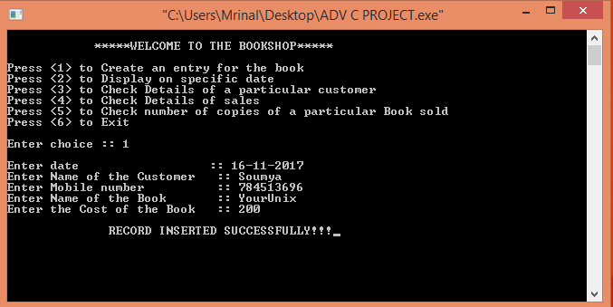

**FIG 7.1 Screen shot of testing**

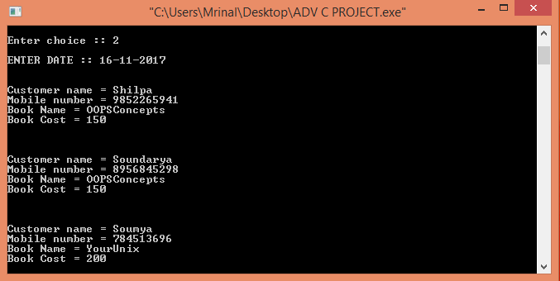

**FIG 7.2 Screen shot of testing**

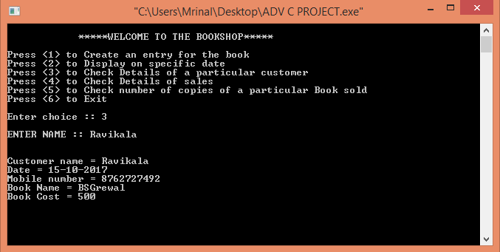

**FIG 7.3 Screen shot of testing**

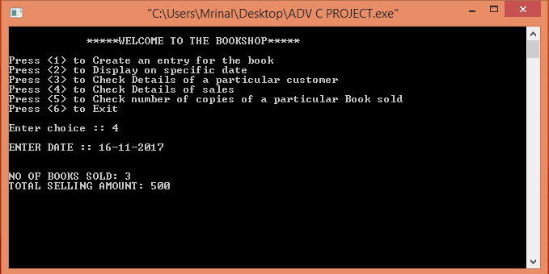

**FIG 7.4 Screen shot of testing**

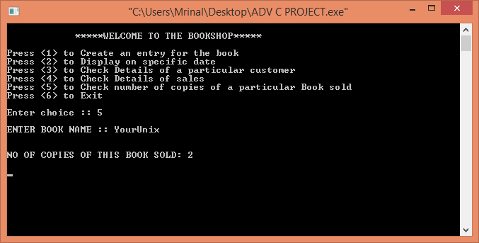

**FIG 7.5 Screen shot of testing**

**8. RESULTS AND DISCUSSIONS**

The program successfully implements the real time book shop management. The program successfully illustrates the use of simple file handling functions in C to store the records.  
It overcomes the disadvantages of the M.S.Excel which was used earlier to store the records. The business of Book shop ownership is spread all over the world. A large record should be maintained in a proper manner for running of bookshop. The proposed system is a window based menu driven system. It reduces the paper work, time needed for doing various tasks etc. Our project upholds the accuracy of data and is user friendly.

**9. LIMITATIONS AND FUTURE ENHANCEMENTS**

1. It will not give the total profit earned by the owner of the book shop .

2. Customers can not search for the available books through this application.

3. It does not have an online selling facility.

4. It is not that much effective compared to online book shopping.

5. Delivery system is not provided.

We can develop this to search availability or stock of the books. In future, it can be enhanced by facilitating credit cash as well as providing home delivery. We can also make this app to calculate net profit or loss.

**10. CONCLUSION**

This system allows the bookshop keeper to store the details of the customer and the sold out book. Easier access to information like customer information and number of copies sold on a particular day. It provides facility of storing data and reduces the paper work. The system is strong enough to provide security to the data. Improved efficiency and effectiveness in administration.

1. **REFERENCES**

1.[**https://prezi.com**](https://prezi.com)

2.[**www.dailyfreecode.com**](http://www.dailyfreecode.com)

3. **Programming in ANSI ,6th Edition by E.Balaguruswami**

4.[[**www.scribd.com**](http://www.scribd.com)

5..[**https://sites.google.com**](https://sites.google.com)